**Eua Tourism**

Tonga celebrates its long history and heritage, and its position as an island nation, through various festivals throughout the year. Some are localized, such as the Vava’u festival and regatta, while others are celebrated nationally, such as the annual Heilala festival. Most Tonga holidays and festivals take place during the dry season, and each presents a unique experience.

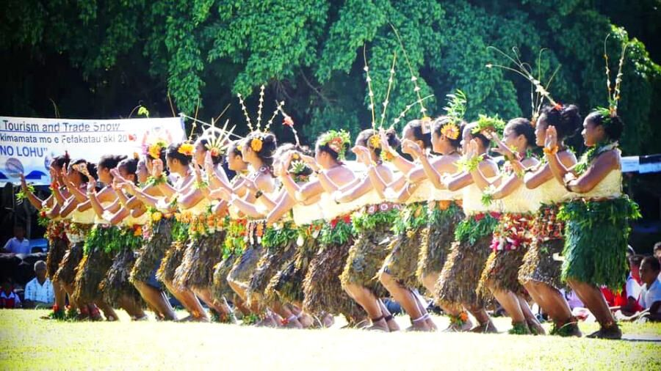

Held on the island of ‘Eua, this is one of the first festivals of the annual calendar. It is held in the second week of May and attracts visitors from around the globe to experience and learn about traditional Tongan culture.